**DEERWALK INSTITUTE OF TECHNOLOGY**

**Tribhuvan University**

**Faculties of Computer Science**

**Bachelors of Science in Computer Science and Information Technology (BSc. CSIT)**

**Course: Computer Graphics (CSC214)**

**Year/Semester: II/III**

**A Lab report on:**

**Implementation of Midpoint Circle Algorithm**

Submitted by:

Name: Parth Poudyal

Roll: 1317

Submitted to:

Binod Sitaula

Department of Computer Science

**Theory**

For a circle, it can be represented using the equation:

$$f\left(x,y\right)=x^{2}+y^{2}-r^{2}$$

Where,

r is the radius of the given circle, and (x, y) be the points on the circle respectively.

Now, to understand:

if for values of (x, y)

$f\left(x,y\right)>0$: the point lies beyond the outlines the circle

$f\left(x,y\right)<0$: the point lies inside the outlines of the circle.

While progressing through the circle from point ( $x_{k}, y_{k})$ to the next point on the circle $\left(x_{k+1}, y_{k+1}\right)$ points can be either

$$\left(x_{k+1}, y_{k+1}\right)=\left(x_{k}+1, y_{k}\right) or, \\ \left(x_{k+1}, y_{k+1}\right)=\left(x_{k}+1, y_{k}-1\right)$$

To determine the next point in the sequence of points, we take the midpoint of the two points given above:

$$\left(x, y\right)=\left(x_{k+1}, y_{k}-\frac{1}{2} \right)$$

Fitting the given midpoint in the given equation of the circle we get:

$$P_{k}= f\left(x_{k+1}, y_{k}-\frac{1}{2} \right)={\left(x_{k+1}\right)}^{2}+{\left(y_{k}-\frac{1}{2} \right)}^{2}-r^{2}$$ if $P_{k}$ be the point next on the circle. The point after that be $P_{k+1}$:

$$P_{k+1}= f\left(x_{k+1}+1 , y_{k+1}-\frac{1}{2} \right)={\left(x_{k+1}+1\right)}^{2}+{\left(y_{k+1}-\frac{1}{2} \right)}^{2}-r^{2}$$ to determine the next point on the sequence, we find the difference between $P_{k}$ and $P_{k+1}$ to get :

$$P_{i+1}=P_{i}+2\left(x_{k}+1\right)+1+\left(y_{k+1}^{2}-y_{i}^{2}\right)-\left(y_{k+1}-y_{k}\right)$$

For different values of $P_{i}$

$$P_{i+1}=P_{i}+2x_{k}+3 :for P_{i}<0 \\ P_{i+1}=P_{i}+2\left(x_{k}-y_{k}\right)+5 :for P_{i}≥0$$

In the equation of the circle with midpoint:

if ${(x}_{k}=0 and y_{k}=r):$

$$P_{i}={\left(0+1\right)}^{2}+{\left(r-\frac{1}{2}\right)}^{2}-r^{2}$$

$$=1+\frac{1}{4}-r^{2}=\frac{5}{4}-r≈\left(1-r\right)$$

**Algorithm**

Step1: Put x =0, y =r in equation 2. We have p=1-r

Step2: Repeat steps while x ≤ y

Plot (x, y)

If (p<0), then set p = p + 2x + 3

Else

p = p + 2(x-y)+5

y =y - 1 (end if)

x =x+1 (end loop)

Step3: End

**Program**

#include <iostream>

#include <graphics.h>

using namespace std;

// Function to draw all eight octants of the circle

void drawCircle(int xc, int yc, int x, int y)

{

putpixel(xc + x, yc + y, WHITE);

putpixel(xc - x, yc + y, WHITE);

putpixel(xc + x, yc - y, WHITE);

putpixel(xc - x, yc - y, WHITE);

putpixel(xc + y, yc + x, WHITE);

putpixel(xc - y, yc + x, WHITE);

putpixel(xc + y, yc - x, WHITE);

putpixel(xc - y, yc - x, WHITE);

}

void bresenhamCircle(int xc, int yc, int r)

{

int x = 0, y = r;

int d = 3 - 2 * r;

drawCircle(xc, yc, x, y);

while (y >= x)

{

x++;

if (d > 0)

{

y--;

d = d + 2 * (x - y) + 5;

}

else

{

d = d + 2 * x + 3;

}

drawCircle(xc, yc, x, y);

}

}

int main()

{

int xc, yc, r;

cout << "Enter the center of the circle (xc, yc): ";

cin >> xc >> yc;

cout << "Enter the radius of the circle: ";

cin >> r;

int gd = DETECT, gm;

initgraph(&gd, &gm, (char*)"");

bresenhamCircle(xc, yc, r);

getch();

closegraph();

return 0;

}

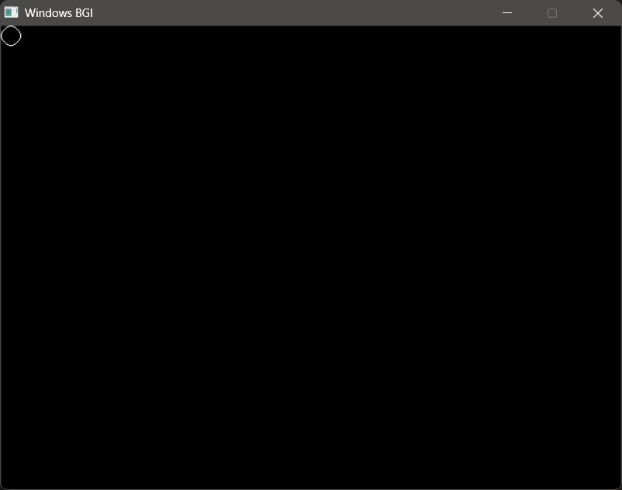**OUTPUT **

**Conclusion**

From this project, I go to understand the application of the Brasenham’s midpoint circle drawing algorithm.